Wausau Area Women’s Top 24 Tournament

What: The Wausau area’s best female bowlers are invited to bowl in the Women’s Top 24 tournament. Bowlers who rank in the top 24 women’s averages qualify. (If anyone declines, the next person in line will be asked to bowl.)
When: May 7, 2022 Check-in: 11:00AM Start: 12:00PM
RSVP: By April 15
Where: Dales Weston Lanes
Cost: $50
Format: Bowl 4 games (scratch) across 8 lanes, cut to top 12. Bowl 2 more games, cut to top 5. Top 5 bowl a stepladder finals.
Bowlers advancing to the stepladder finals will be paid.

Name | Center

Please return this form to Sue Walter by April 15.
Call/text/FB message Sue at 715 571-0619 to let her know you will be bowling. You can also indicate “Going” on the Facebook Event page to sign up.
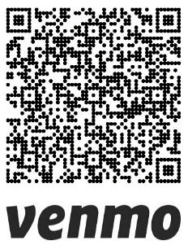
Please pre-pay for this tournament by paying Sue in person or
Venmo @Sue-Walter-12

